缩减变量的Y2模型,变量参见下方.

97到15年

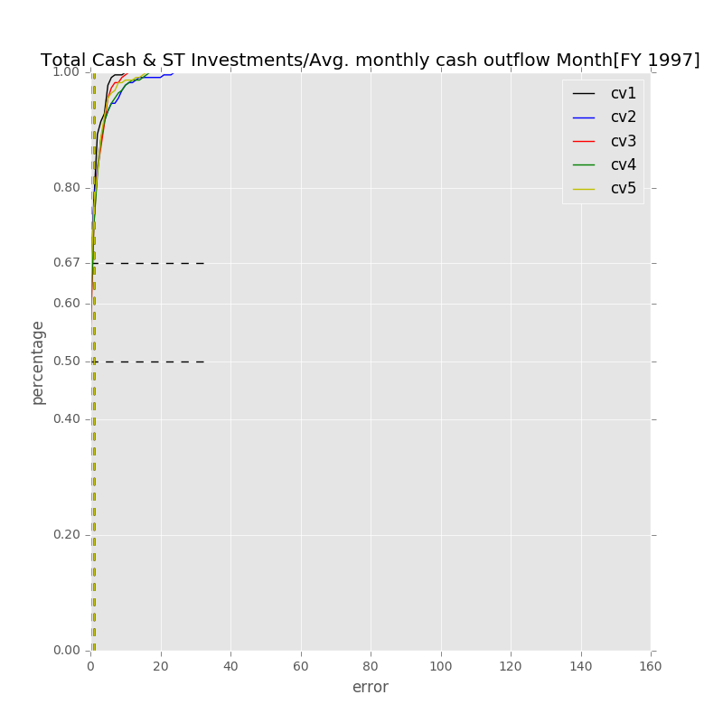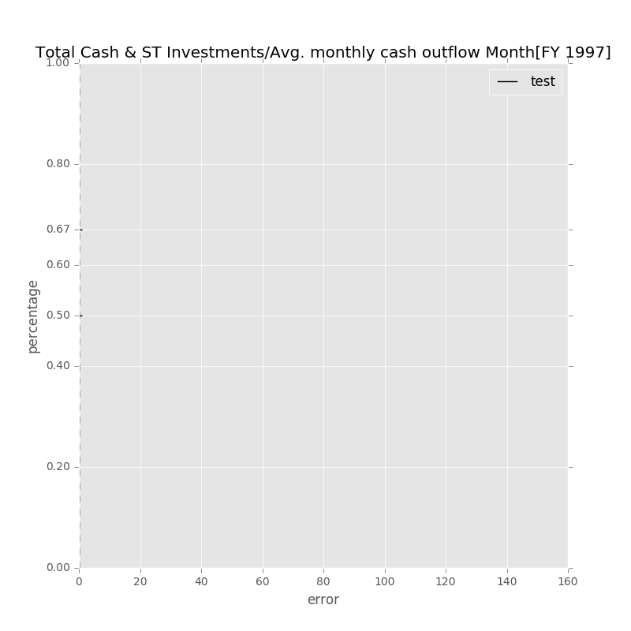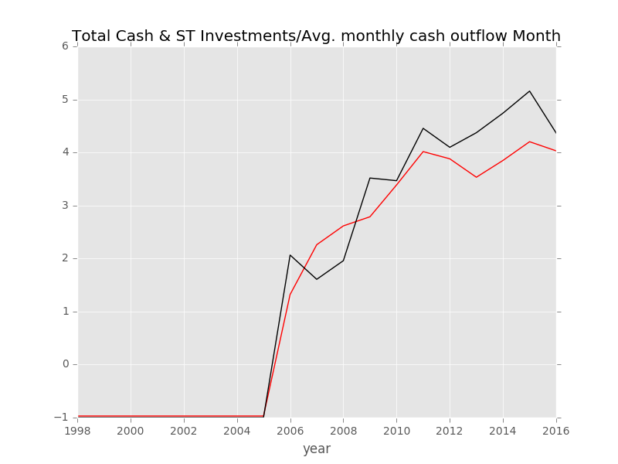

误差较小,在第二张图上显示不出来.

Label: Total Cash & ST Investments/Avg. monthly cash outflow Month[FY 1997]

Min Error: 0.029814

Mean Error: 0.356825

Median Error: 0.216930

Max Error: 0.954462

Feature importance:

Net Income Margin % : 0.083755

Gross Margin % : 0.082724

Total Liabilities/Total Assets % : 0.080223

Net Property, Plant & Equipment/ Total Assets % : 0.079980

Avg. Cash Conversion Cycle (Days): 0.078359

Cash from Ops./Net Income% : 0.075297

Total Asset Turnover : 0.073878

Rev YOY % : 0.072266

Avg. Days Payable Out. (Days): 0.066959

Return on Equity % : 0.065362

Total Debt/Equity % : 0.061432

Goodwill/Total Revenue % : 0.060854

R&D Exp./Total Revenue % : 0.060198

Payout Ratio (%): 0.036931

准入资本市场难度: 0.015896

Cash flow risk(0:low; 1: high): 0.005885

Total Min: 0.029814

Total Mean: 0.356825

Total Median: 0.216930

Total Max: 0.954462

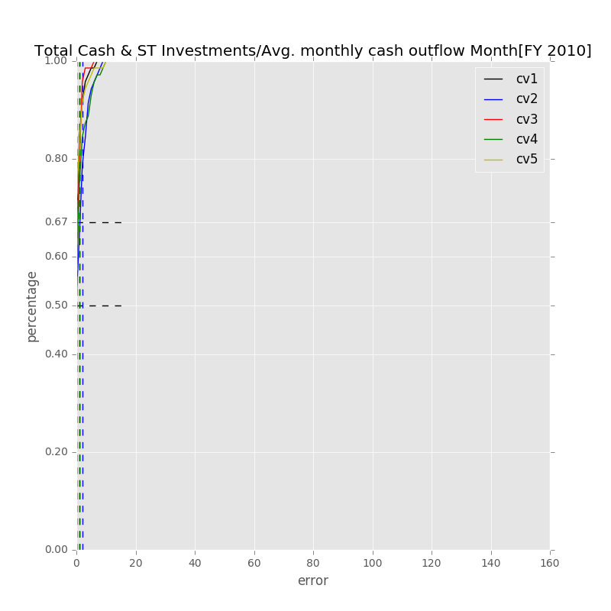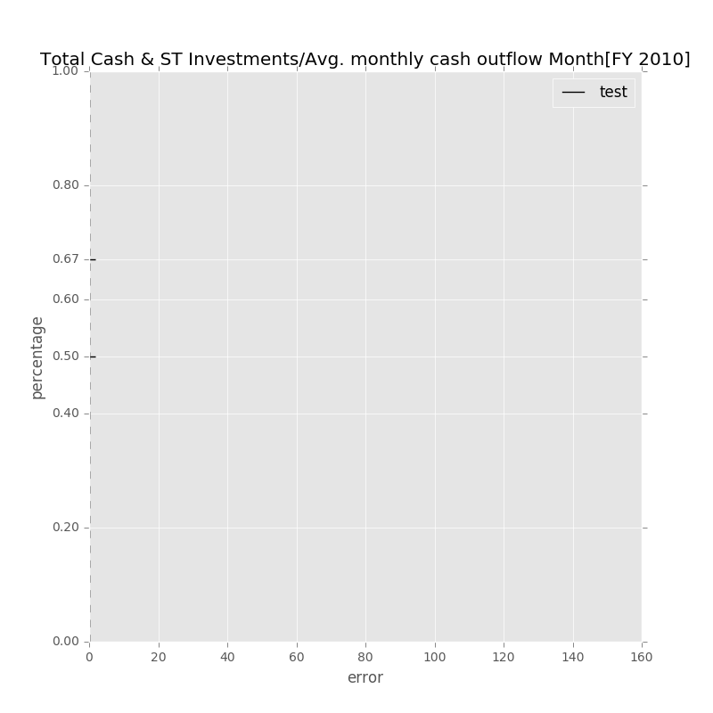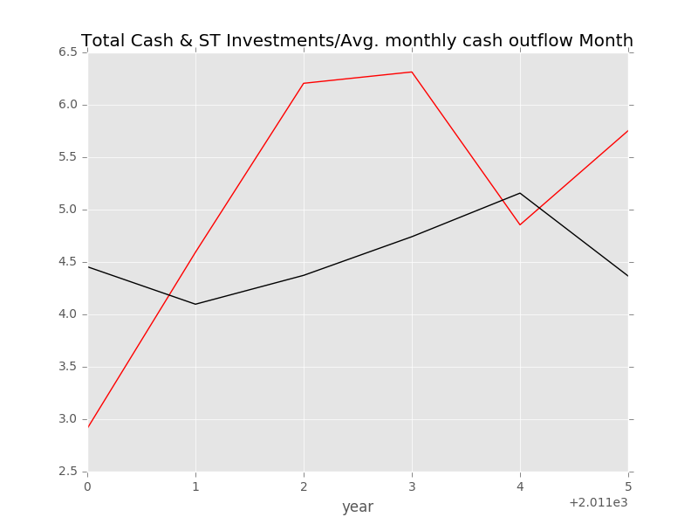

Label: Total Cash & ST Investments/Avg. monthly cash outflow Month[FY 2010]

Min Error: 0.302401

Mean Error: 1.189004

Median Error: 1.465725

Max Error: 1.832698

Feature importance:

Avg. Cash Conversion Cycle [FY 2010] (Days): 0.078761

Net Income Margin % [FY 2010]: 0.077710

Avg. Days Payable Out. [FY 2010] (Days): 0.074638

Net Property, Plant & Equipment/ Total Assets % [FY 2010]: 0.074267

Goodwill/Total Revenue % [FY 2010]: 0.074241

Total Liabilities/Total Assets % [FY 2010]: 0.073179

Gross Margin % [FY 2010]: 0.073091

Total Asset Turnover [FY 2010]: 0.072197

Rev YOY % [FY2010]: 0.072007

Total Debt/Equity % [FY 2010]: 0.070265

Return on Equity % [FY 2010]: 0.065165

Cash from Ops./Net Income% [FY 2010]: 0.063469

R&D Exp./Total Revenue % [FY 2010]: 0.059201

Payout Ratio [FY 2010] (%): 0.045425

准入资本市场难度: 0.021165

Cash flow risk(0:low; 1: high): 0.005218

Total Min: 0.302401

Total Mean: 1.189004

Total Median: 1.465725

Total Max: 1.832698